HEGNER QUICK CLAMP vs STANDARD BLADE CLAMPS

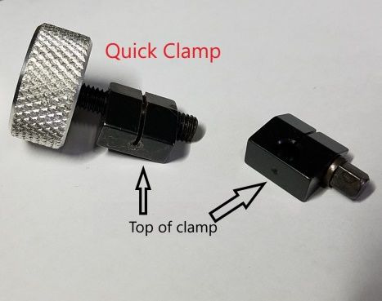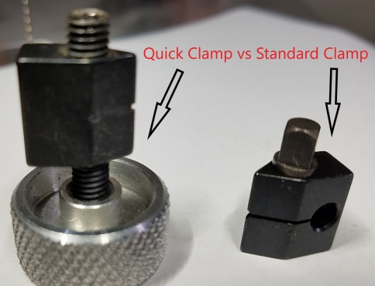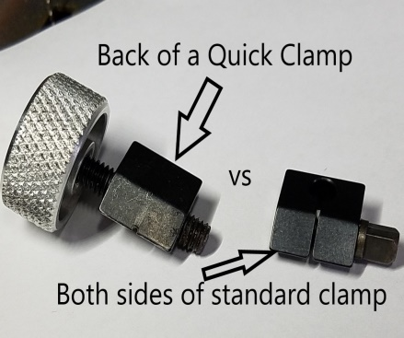
The patented standard blade clamp is simple in its design and highly effective. It consists of only 2 parts: the clamp body and the tuff screw. The tuff screw goes thru the center of the clamp and when tightened causes the clamp to grip the blade at the bottom point of the clamp where it can pivot in the ‘V’ of the saw arms. Centered in the ‘V’ and correctly tightened using the tuff wrench, the blade will not slip out and the pivoting clamp reduces stress on the blade, i.e. reduces blade breakage. Many users prefer the standard clamps for these reasons.
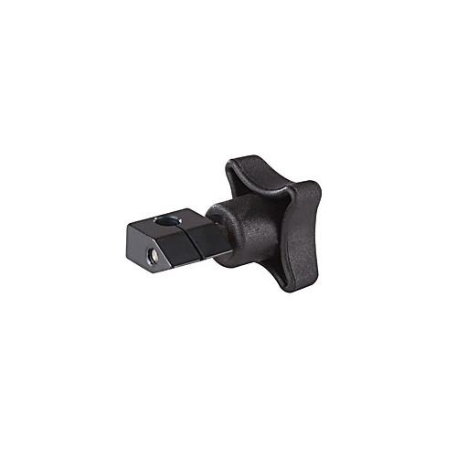
Standard blade clamps can also be used with a wing nut instead of the tuff screw eliminating the need to use the tuff wrench.

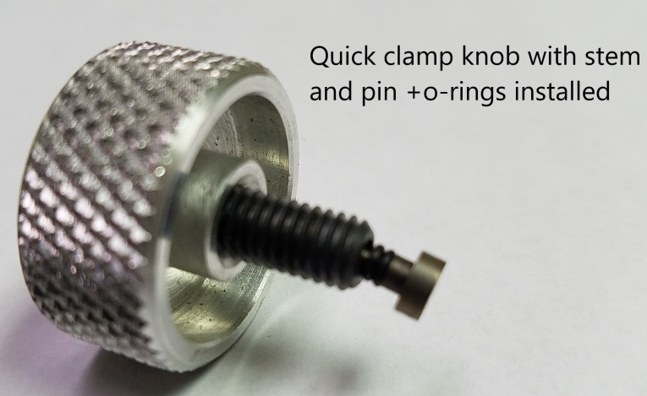
The Quick Clamp has a more complex design. It consists of 5 components; The clamp body, knurled knob, the hollowed knob stem with threads that is glued into the knurled knob, a pivot pin with O-rings that sits in the knob stem, and a separate set screw glued into the left side of the clamp body. The knob with stem and pivot pin screws into the right side of the clamp body and presses the blade against the set screw when tightened. The front of the clamp has a slot into which the blade mounts until it rests against the solid back of this clamp. Due to the weight of the Quick Clamp, it should not pivot and therefore the top of this clamp has a small indentation allowing the screw on the top of the blade holder to hold it in place, at the same time providing a stop for the top of the blade. This clamp was designed to facilitate quicker blade changes for those users doing many interior cuts. Because it does not pivot, it puts some additional stress on the top of the blade.
The tuff screw of the regular clamps and the knob with stem of the Quick Clamp are not interchangeable.

